

Master’s thesis  
Geoinformatics

ASSESSING PEDESTRIANS’ EXPOSURE TO TRAFFIC NOISE WITH SPATIAL ANALYSIS: THE EFFECTS OF HOME LOCATION AND ROUTE CHOICE

Joose Helle  
2019

Supervisors:  
Tuuli Toivonen  
Henrikki Tenkanen

University of Helsinki  
Faculty of Science  
Department of Geosciences and Geography

PL 64 (Gustaf Hällströmin katu 2)   
00014 University of Helsinki

|  |  |  |  |
| --- | --- | --- | --- |
| Tiedekunta/Osasto Fakultet/Sektion – Faculty  Faculty of science | | Laitos/Institution– Department  Department of Geosciences and Geography | |
| Tekijä/Författare – Author  Joose Helle | | | |
| Työn nimi / Arbetets titel – Title  Assessing pedestrians’ exposure to traffic noise with spatial analysis: the effects of home location and route choice | | | |
| Oppiaine /Läroämne – Subject  Geography, geoinformatics | | | |
| Työn laji/Arbetets art – Level  Master’s thesis | Aika/Datum – Month and year  August 2019 | | Sivumäärä/ Sidoantal – Number of pages |
| Tiivistelmä/Referat – Abstract | | | |
| Avainsanat – Nyckelord – Keywords | | | |
| Säilytyspaikka – Förvaringställe – Where deposited  HELDA | | | |
| Muita tietoja – Övriga uppgifter – Additional information | | | |





|  |  |  |  |
| --- | --- | --- | --- |
| Tiedekunta/Osasto Fakultet/Sektion – Faculty  Matemaattis-luonnontieteellinen tiedekunta | | Laitos/Institution– Department  Geotieteiden ja maantieteen laitos | |
| Tekijä/Författare – Author  Joose Helle | | | |
| Työn nimi / Arbetets titel – Title | | | |
| Oppiaine /Läroämne – Subject  Maantiede, geoinformatiikka | | | |
| Työn laji/Arbetets art – Level  Pro gradu -tutkielma | Aika/Datum – Month and year  Elokuu 2019 | | Sivumäärä/ Sidoantal – Number of pages |
| Tiivistelmä/Referat – Abstract | | | |
| Avainsanat – Nyckelord – Keywords | | | |
| Säilytyspaikka – Förvaringställe – Where deposited  HELDA | | | |
| Muita tietoja – Övriga uppgifter – Additional information | | | |

**TABLE OF CONTENTS**

1 Introduction 1

2 Background 3

2.1. Noise 3

2.2. Traffic noise in legislation 3

2.3. Alternative measures of pedestrian accessibility - travel time is not enough 3

2.4. Approaches in assessing exposure to traffic noise 4

2.5. Route optimization in GIS 5

2.5.1. Graph theory 5

2.5.2. Least cost path 5

2.5.3. Optimizing short and green paths 5

2.5.4. Environmental impedance function 5

2.6. Web GIS 5

2.6.1. Concepts and recent developments 5

2.6.2. Interactive web map applications 5

3 Material & Methods 6

3.1. Overview of the methods 6

3.2. Study area 6

3.3. Materials 7

3.3.1. Modelled traffic noise data 8

3.3.2. OpenStreetMap data 8

3.3.3. Register based origin-destination (OD) commuting data 9

3.3.4. Routing service of the local public transport authority 9

3.4. Technical framework 9

3.5. Route optimization method 11

3.5.1. Environmental impedance function 11

3.5.2. Network acquisition and manipulation 11

3.5.3. Optimization of short and quiet paths 14

3.5.4. Comparison of short and quiet paths 15

3.6. Quiet path route planner web application 16

3.6.1. Overview of the application 17

3.6.2. Technical architecture 17

3.7. Assessment of pedestrians’ exposure to traffic noise at neighborhood level 18

3.7.1. Overview of the analysis 18

3.7.2. Estimation of local PT stops’ utilization rates by commutes 20

3.7.3. Least cost path calculations – short and quiet paths 21

3.7.4. Spatial aggregation of exposures to traffic noise along the paths 22

3.7.5. Assessment of pedestrians’ potential to reduce exposure to traffic noise with route choices 22

4 Results 22

4.1. Quiet path route planner web application 22

4.2. Spatial patterns in pedestrians’ exposures to traffic noise 26

5 Discussion 26

5.1. Could traffic noise be used as a proxy for overall walkability? 26

5.2. Indirect large-scale assessment of pedestrians’ exposures to traffic noise can reveal significant areal differences in walking conditions 26

5.3. Considerable share of the exposure to traffic noise can often be avoided by taking an alternative path 27

5.4. Definition of the environmental impedance function is critical yet somewhat arbitrary in quiet path optimization 27

5.5. Alternative quiet paths need to be calculated to suit different situations and users with varying preferences 27

5.6. Publishing a green path routing application online can facilitate citizens to choose healthier paths 27

5.7. More efficient technical implementation is required to enable real-time green path route optimization 27

6 Conclusions 27

7 References 27

# Introduction

In the growing cities, active transport modes are getting increasing attention among policy makers and urban planners. The term active transport is usually used to refer to walking and cycling but also other active transport modes such as E-scooters and even city rowboats are emerging in urban context. Undoubtedly, walking remains the most popular mode of active transport since it doesn’t require any accessories and is essential part of all itineraries made by public transport.

It has been shown that active transport modes provide strong health benefits to their users (Pucher & Buehler, 2010) and also to others since they can help to reduce congestion. Hence, cities often have a strong willingness to promote and facilitate active transport modes for urban mobility. In encouraging people to e.g. walking, it is essential for the cities to provide sufficient infrastructure and comfortable environments to make walking secure and easy.

Multiple factors affect the ease with which active transport is applicable in different urban environments. While infrastructure for cycling is predominantly defined by the more or less exclusive network of cycleways and bike lanes, the one for walking (footpaths, sidewalks etc.), in the other hand, is denser and more evenly distributed. However, not only the physical properties of the walking network define its applicability and desirability (walkability), but also multiple more or less subjective factors need to be considered (Maghelal & Capp, 2011). These include variables such as safety, building design, openness of spaces, proximity to opportunities, air quality and green spaces.

Many of the factors limiting walkability and other active transport modes are often caused by (or at least related to) other, “non-human”, users of the urban space. Evidently, one of the most significant of these is vehicular traffic and the infrastructures supporting it. Vehicular traffic affects walkability and bikeability by introducing large and typically unpleasant structures to urban spaces. From the active transport point of view, these structures act as barriers fragmenting the active transportation networks and thus reduce the opportunities for walking and cycling.

Furthermore, vehicular traffic consumes the opportunities for active transport with at least two “invisible” ways. Firstly, since most of the traffic is powered by gasoline engines, it has a strong negative impact on air quality due to the exhaust gases. According to numerous studies, these urban air pollutions can cause or worsen many lung diseases such as asthma or even cancer. Secondly, both the engines and the wheels of the vehicles cause noise. Amount of noise is related to the flow and speed of the traffic and to the type of the road surface. Increased but also varying traffic noise levels are typical to highways and other major roads. According to several studies, there seem to be some kind of relationship between pedestrians’ exposure to traffic noise and health, namely stress levels and problems related to blood circulation (Babisch, Beule, Schust, Kersten, & Ising, 2005; Ising, Dienel, Günther, & Markert, 1980).

In this study, the broad and comprehensive definition of walkability is not trying to be addressed per se. Instead, from the perspective of walkability research, this study can be seen as an attempt to capture a narrow but important component of walkability; exposures to traffic noises have the potential to offer relevant spatial information of routes and areas of low walkability.

It is anticipated, yet not explicitly verified in the study, that traffic noise levels have a strong spatial correlation with also other negative impacts of traffic such as air pollution and presence of large unwalkable (and unpleasant) infrastructures. With respect to this assumption, the methods developed in the study are suitable for identifying areas where improvements to walking conditions are most needed.

Given this context, the main objectives of the study were defined as follows:

1. Discover neighborhood-level spatial patterns in pedestrians’ exposures to traffic noise with respect to citizens’ daily pedestrian activities.
2. Develop and implement a “quiet path” routing application that optimizes more pedestrian-friendly walking routes by minimizing exposure to traffic noise pollution.
3. Publish the quiet path routing application as proof-of-concept (POC) quiet path planner web application.

In other words, the study aims to facilitate both 1) city planners to discover areas of problematic walking conditions (with respect to traffic noise) and 2) citizens to choose healthier (quieter) walking routes for their daily mobility (via the “quiet route planner” web application). Latter can be seen as a short-term and the first as long-term solution to the problem of minimizing pedestrians’ exposure to traffic noise.

# Background

## Noise

Noise, in general, can be defined simply as undesirable sound. Other defining words unwanted, loud, unpleasant, disruptive and unintended aim to address the subjective nature of noise. The lack of explicit definition of noise derives from noise being indistinguishable from sound in physics; both are fundamentally just vibrations through air (or other transmission medium). Yet, the concept of noise is crucial in the research of negative health effects of high and unpleasant sounds. If a sound is described as noise, it implies that its assumed perception or health effect is negative as opposed to neutral or positive.

While there are major differences in how different people experience sound and which of all sounds are regarded as noise, some loud sounds are generally regarded as noise. Moreover, all sounds can be coarsely divided into three classes based on the general perception of them:

1. Sounds which most people perceive as desirable, pleasant or harmless (e.g. the sounds of flowing water and light wind)
2. Sounds which some people perceive as pleasant and some as noise depending on the individual, sound level, other sounds and circumstances (e.g. the sounds of dishwasher, quiet background chat and calm bird singing).
3. Sounds that most people regard as noise (e.g. the sounds of vehicular and aerial traffic, construction sits, babies crying and people yelling).

Previous research on health impacts of noise is usually focused on the sounds that most people perceive as noise (3).

## Traffic noise in legislation

## Alternative measures of pedestrian accessibility - travel time is not enough

In accessibility researh, travel time is often used as the main measure of accessibility; how many minutes it takes to get from origin to destination? The advantages of such approach are obvious: it is, by definition, simple and enables comparison of accessibility between different travel modes and study areas. In previous research, it has been pointed out that travel time has strong impact on route and travel mode choises.

However, several weaknesses in using only travel time as a measure of accessibility have been identified.

Pedestrian, as an individual who moves in space and time, is of all the road users most exposed to the environmental conditions surrounding the taken path. The perception of these conditions can be classified by the human senses to at least three major categories:

1. Touch: how does the environment feel like? Is the air cold, humid, hot or dry?
2. Taste and smell: how is the air to breathe; does it smell clean?
3. Visual: how does the environment look like? How many sights are visible throughout the path? What is the ratio between natural and artifical sights (e.g. green vs. built)?
4. Hearing; how does the environment sound like? Are there more sounds or noises, or is it mostly quiet?

When considering pedestrian’s perceptions with respect to these five senses, it becomes clear that only the travel time is rather fuzzy measure of the perceived impdeance of a given walk.

## Approaches in assessing exposure to traffic noise

While air pollution is often be challenging to quantify, measure and model (and tends to be highly dynamic with respect to weather conditions), traffic noise can be measured and modelled in a more straightforward manner. Also, the latter has the potential to offer spatially accurate information of urban traffic flows and their side-effects. Vehicular traffic noise levels have been spatially modelled in many cities with fairly high spatial resolution. The modeling has been done using mathematical models that consider traffic count data, noise measurements and 3D data of materials and geometries of urban infrastructures (buildings, roads, walls etc.).

Since negative health impacts of vehicular traffic (to pedestrians) can compromise the potential health benefits of walking (Tainio et al., 2016), means for assessing pedestrians’ exposure to the negative effects of traffic have been developed in the previous literature. Clearly, two distinguishable approaches exist for addressing mobile individuals’ exposures to traffic noise and air pollution:

1. Direct way: using measurement instruments attached to members of a study group and tracking them temporally and spatially (e.g. Apparicio, Carrier, Gelb, Séguin, & Kingham, 2016; Cole-Hunter, Morawska, Stewart, Jayaratne, & Solomon, 2012).
2. Indirect way: using spatial analysis combining modelled traffic noise or air pollution data and either tracked or modelled routes of people (e.g. Sheng & Tang, 2011; Whyatt et al., 2007).

## Route optimization in GIS

### Graph theory

### Least cost path

### Optimizing short and green paths

In the previous literature, the concepts green, healthy, sustainable, safe and quiet paths have been introduced to address the problem of finding alternative walking routes. Taking environmental factors into account in solving route optimization problems clearly seem to have the potential to generate healthier or in other ways better walking routes (e.g. Lwin & Murayama, 2011, 2013; Quercia, Schifanella, & Aiello, 2014; Ribeiro & Mendes, 2011). In the context of this study, the concept quiet path is used to refer to routes of less noise exposure.

### Environmental impedance function

## Web GIS

### Concepts and recent developments

### Interactive web map applications

# Material & Methods

## Overview of the methods

Overview of the methods and their internal dependencies is illustrated in Figure 1.

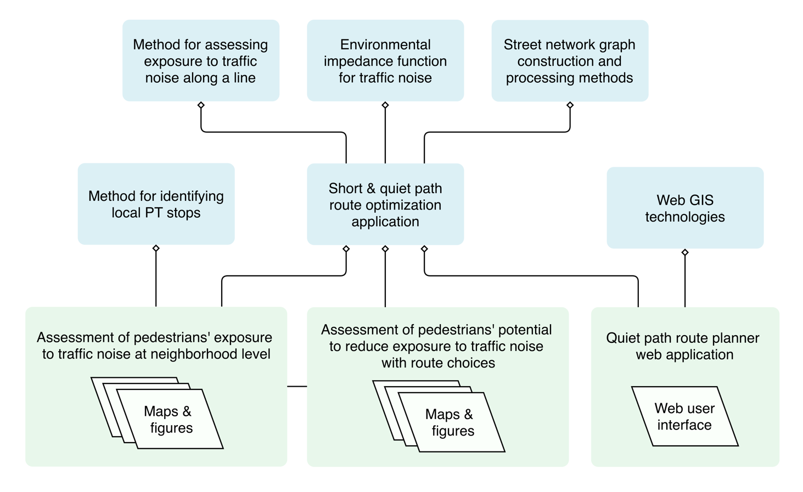

Figure 1. Illustration of the internal methodological dependencies of the study.

## Study area

The methodology and results of this thesis are highly technical (mostly software and scripts) and hence the study area of the thesis is partially irrelevant. Nonetheless, particularly the assessment of pedestrians’ exposure to traffic noise is also spatially interesting, given that the results reveal areal patterns and inequalities in pedestrians’ exposures to traffic noise.

The study area of the thesis is defined by the extent of the Traffic noise zones in Helsinki, i.e. the municipal boundaries of the city of Helsinki (Figure 2). Some of the islands in southern Helsinki were excluded since the traffic noise data did not cover them. However, the concepts and methods are applicable to any area for which modelled traffic noise surfaces and OpenStreetMap data are available. Such areas include for example major cities in Europe due to traffic noise assessments required by EU directives and (almost) global coverage of OSM.

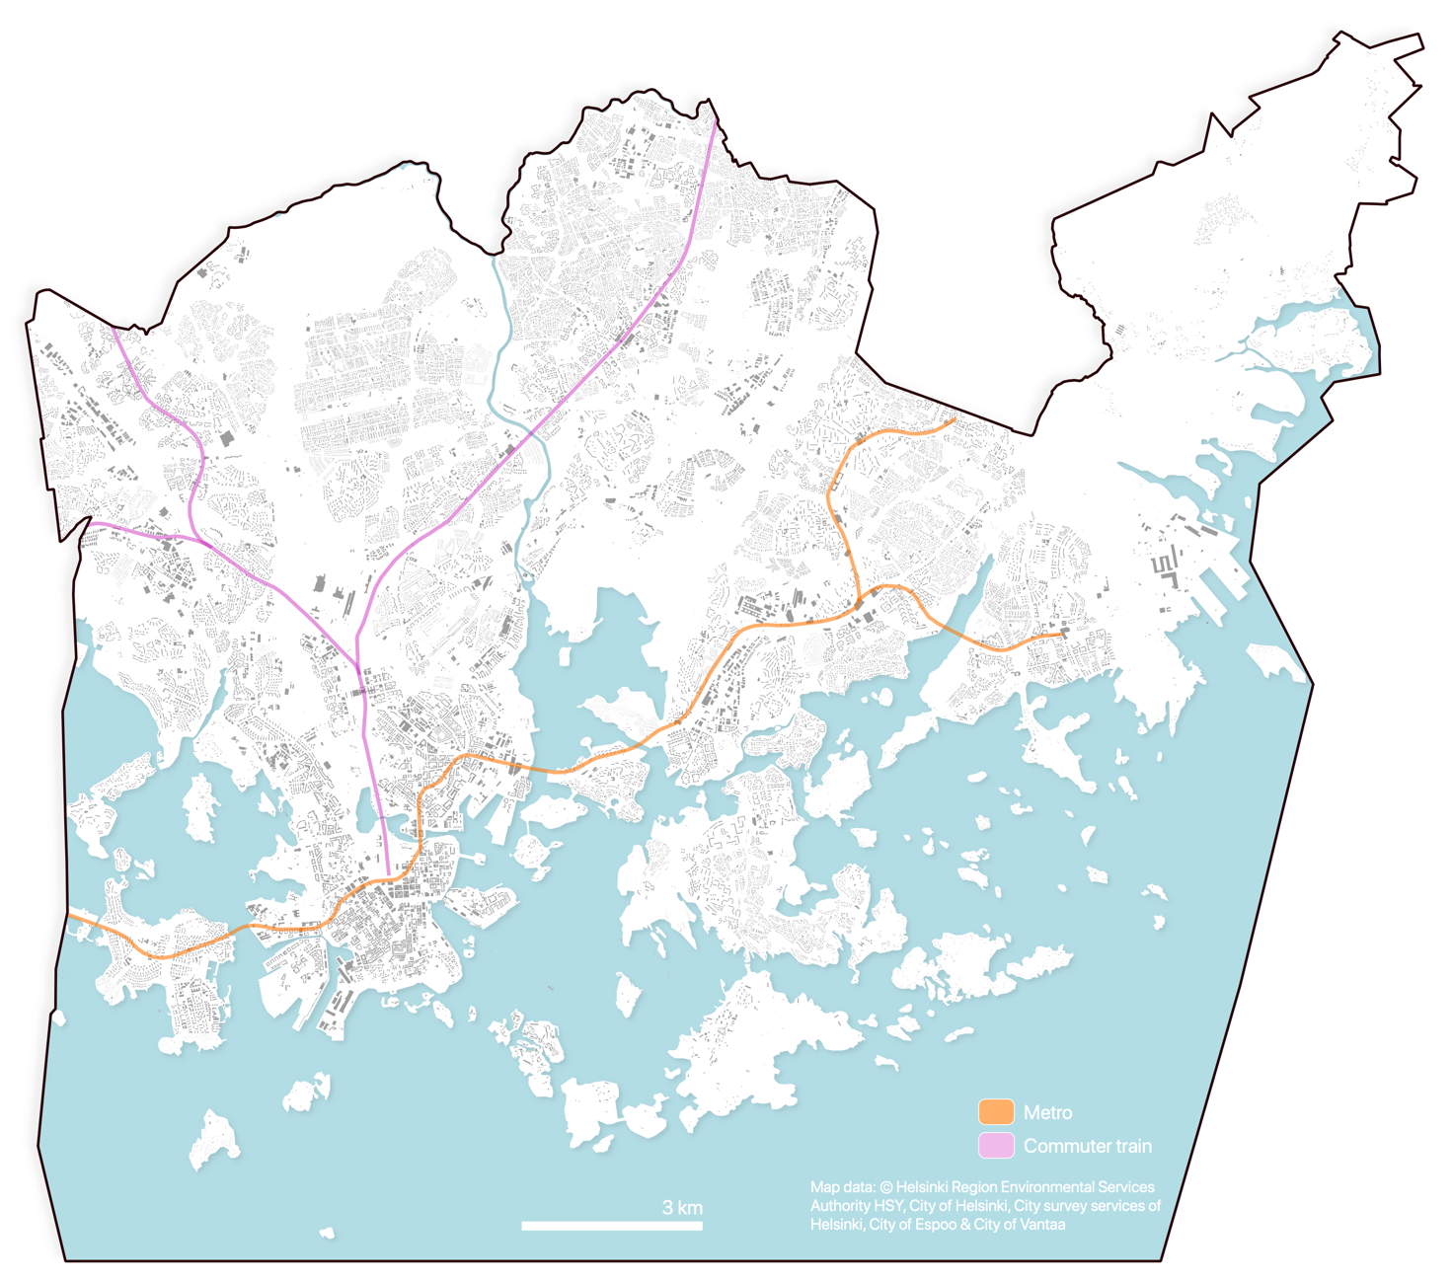

Figure 2. Map of the study area; extent of the city of Helsinki excluding the southern islands.

## Materials

Table 1. Materials that were used in the study.

|  |  |  |  |
| --- | --- | --- | --- |
| Name | Source | Description | Use in the study |
| Traffic noise zones in Helsinki 2017 | Urban Environment Division of city of Helsinki  (Helsingin kaupunkiympäristön toimiala) | Modelled traffic noise surfaces as polygon layer covering the city of Helsinki. Minimum and maximum noise levels are stored as attribute information. | Traffic noise exposures are based on the traffic noise surfaces (zones) of this dataset. |
| 250m statistical grid | Statistics Finland | 250m * 250m polygon grid layer. | Center points of the grid layer were used as origins in the routing analysis. Grid cell polygons were used in visualizing the results. |
| YKR-commuting data | Finnish Environment Institute (SYKE) / Statistics Finland | Commutes between 250m statistical grid cells as table. One row in the table represents the total number of commutes between two grid cells. | Utilization rates of local PT stops were calculated based on PT itineraries planned for the commutes. |
| OpenStreetMap: highways | © OpenStreetMap contributors | All walkable highways and paths as network segments. | A network graph suitable for route optimization was constructed from the data. |
| Digitransit Routing API | Helsinki Region Transport (HRT) | Routing service for planning public transport itineraries as an application programming interface (API). | Local PT stops were identified by requesting PT itineraries for the commutes form Digitransit routing API. |

### Modelled traffic noise data

The traffic noise data includes modelled traffic noise surfaces with minimum and maximum traffic noise levels for each surface. The traffic noise levels are aggregated with 5dB intervals. Both the analysis of exposures to traffic noise and the quiet path route optimization method heavily rely on modelled traffic noise surface data.

The modelling was conducted by Sito Oy as a commission from the city of Helsinki (*City of Helsinki: strategic noise mapping*, 2017). Many aspects of noise and acoustics were taken into account in the modeling, such as traffic flow, traffic speed, the three-dimensional surface model of the city, buildings, sound barriers and acoustic properties of different materials.

### OpenStreetMap data

Highway features used in walkable network construction were downloaded from OpenStreetMap (OSM). The relevant OSM features were extracted by from OSM via query service which allowed using specific OSM tags (key-value pairs) to request only the features of interest.

OSM data has often been used in optimizing walking routes as it often includes more comprehensive set of walkable network features than other data sources (e.g. paths, platforms and tracks).

### Register based origin-destination (OD) commuting data

* Statistics Finland / Syke
* Commutes as origin-destination flows
* Aggregated to 250 m grid
* Subset of commutes with origin in Helsinki was extracted
* Suitable for identifying also residential areas (as origins of commutes)

### Routing service of the local public transport authority

* Digitransit application programming interface (API)
* Only for identifying local PT stops

## Technical framework

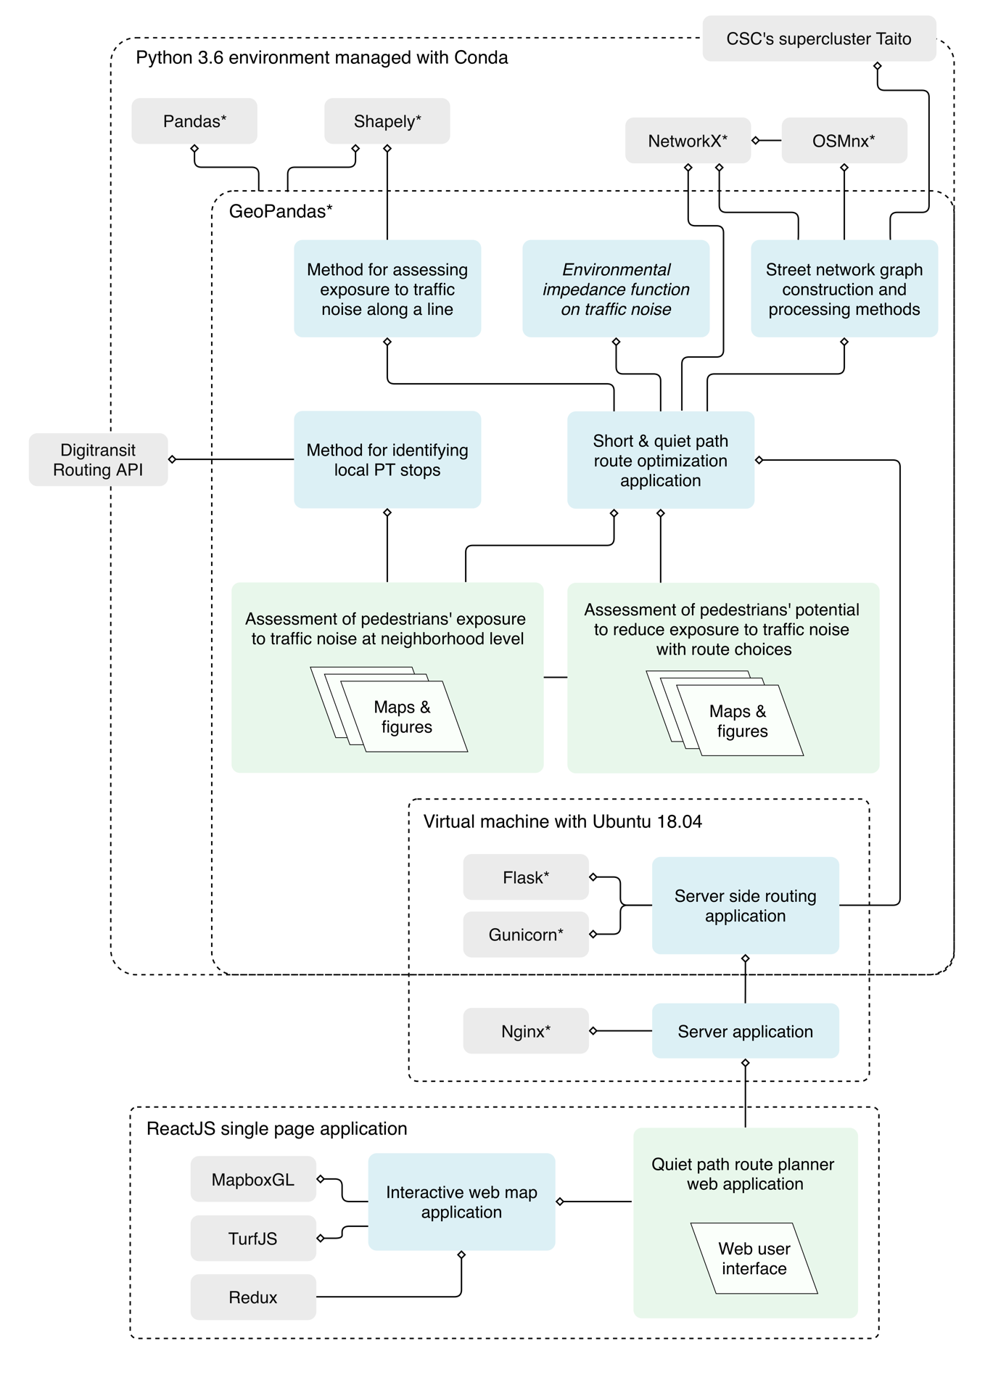

Figure 3. Technical framework of the study: internal (blue) and external (grey) technical dependencies (* = Python library). Numerous external dependencies of the used Python libraries are not included in the graph.

## Route optimization method

### Environmental impedance function

The equation for calculating adjusted edge costs suitable for quiet path route optimization was defined as:

|  |  |
| --- | --- |
| $$C_{e}=d_{e}+C_{en}$$ | (1) |

where $C_{e}$ is thetotal cost of the edge; $d_{e}$ is the length of the edge (in meters) and $C_{en}$ is the additional noise cost of the edge. The following equation was developed to model $C_{en}$:

|  |  |
| --- | --- |
| $$C_{en}=( \sum_{i={dB}_{min}}^{{dB}_{max}}{d_{{dB}_{i}}}× a_{{dB}_{i}} ) × nt$$ | (2) |

where ${dB}_{i}$ refers to a 5 dB range with ${dB}_{i}$ as the lower value (e.g. 55 dB refers to dB-range of 55–60 dB), $d_{{dB}_{i}}$ is the contaminated distance (m) of the 5 dB range from ${dB}_{i}$ (e.g. 14 m of 55–60 dB) along the edge geometry; $a_{{dB}_{i}}$ is a dB-specific noise cost coefficient (between 0.0–0.6, Table 2) and 𝑛𝑡 is a “personal” noise tolerance coefficient (between e.g. 0.1–40).

Table 2. Cost coefficients for different traffic noise levels.

|  |  |
| --- | --- |
| Traffic noise level (dB) | Noise cost coefficient ( $a_{{dB}_{i}})$ |
| 45–50 | 0.0 |
| 50–55 | 0.1 |
| 55–60 | 0.2 |
| 60–65 | 0.3 |
| 65–70 | 0.4 |
| 70–75 | 0.5 |
| 75–80 | 0.6 |

### Network acquisition and manipulation

The following three steps were required to acquire and prepare network to a graph suitable for optimizing least cost paths paths:

1. Walkable network acquisition from OpenStreetMap (Figure 4).
2. Spatial join of contaminated distances to different noise levels to edges (Figure 5).
3. Calculating new noise tolerance specific edge costs to edge attributes (Figure 6).

Network of walkable streets was obtained from OpenStreetMap via Overpass API.

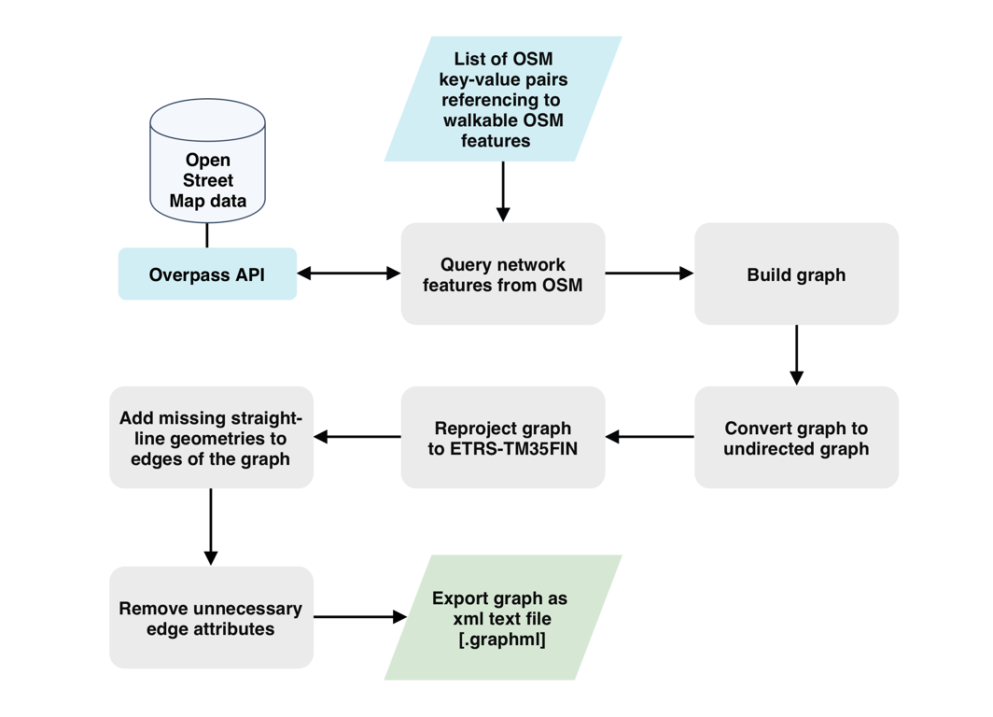

Figure 4. Workflow of network (graph) acquisition and construction.

Figure 5. Workflow of extracting exposures to traffic noise (contaminated distances) to the edges of the graph.

Figure 6. Workflow of calculating and adding noise tolerance specific edge costs as new edge attributes.

### Optimization of short and quiet paths

Figure 7. Workflow of least cost path routing method for short and quiet paths.

### Comparison of short and quiet paths

A set of metrics was developed to enable efficient comparison of exposures to traffic noise between alternative paths (Table 3). The key challenge in developing such indexes was compressing information of contaminated distances to different traffic noise levels to singular index describing the total cumulative exposure to traffic noise along a path. The noise cost equation developed for the environmental impedance function (2) was applied to convert the contaminated distances into compressed *total exposure to traffic noise* -index. Only the simple form of the equation was needed, leaving out the personal noise tolerance coefficient (=> *nt =* 1). The idea of using this approach was derived from the logic that if the developed environmental impedance function served well in optimizing quiet paths, the same function would also be valuable in comparing exposures to traffic noise between complete paths (as well as between network edges).

Table 3. Indexes describing exposure to traffic noise along a path and reduction in exposure to traffic noise along a quiet path.

|  |  |  |  |  |
| --- | --- | --- | --- | --- |
| Index | Equation |  | | Description |
| Exposure / contaminated distance to traffic noise of dBi (m) | $$E_{db} = d_{{dB}_{i}}$$ | | (3) | The total distance of exposure to traffic noise of specific dB along the path. |
| Total exposure to traffic noise (index) | $$E_{t} = \sum_{i={dB}_{min}}^{{dB}_{max}}{d_{{dB}_{i}}}× a_{{dB}_{i}} )$$ | | (4) | Similar as environmental impedance function (2) but without personal noise tolerance coefficient (*nt* = 1). |
| Reduction in total exposure to traffic noise (%) | $$E_{d} = \frac{ΔE_{t}}{E_{ts}} *100 = \frac{E_{tq}-E_{ts}}{E_{ts}} *100$$ | | (5) | Reduction (%) in cumulative exposure to traffic noise between short and quiet path. |
| Distance normalized exposure to traffic noise (index) | $$E_{n} = \frac{E_{t}}{E_{t_{max}}} = \frac{E_{t}}{a_{max}* d} = \frac{E_{t}}{0.6 * d}$$ | | (6) | *Et*of the path normalized by dividing it with maximum theoretical *Et*for a path of same distance. |
| Quiet path score | $$P_{q_{score}} = \frac{ΔE_{t}}{Δd} = \frac{E_{ts}-E_{tq}}{d_{q}-d_{s}}$$ | | (7) | Performance of the quiet path in avoiding exposure to traffic noise with respect to difference in total path distances between short and quiet path. |

${dB}_{i}$ = 5 dB range with ${dB}_{i}$ as the lower value (e.g. 55 dB refers to dB-range of 55–60 dB) $d_{{dB}_{i}}$ 
 = contaminated distance of ${dB}_{i}$ (e.g. 14 m of 65–70 dB) along the path geometry $a_{{dB}_{i}}$ 
 = dB-specific noise cost coefficient (between 0.0–0.6, Table 2) $a_{max}$ 
 = highest noise cost coefficient (Table 2; 75–80 dB: 0.6)

## Quiet path route planner web application

### Overview of the application

The quiet path route planner was developed as a proof of concept to demonstrate the applicability of the quiet path routing method in practical situations. Also, it facilitated developing and adjusting the quiet path routing method by enabling testing the method on demand in real situations.

### Technical architecture

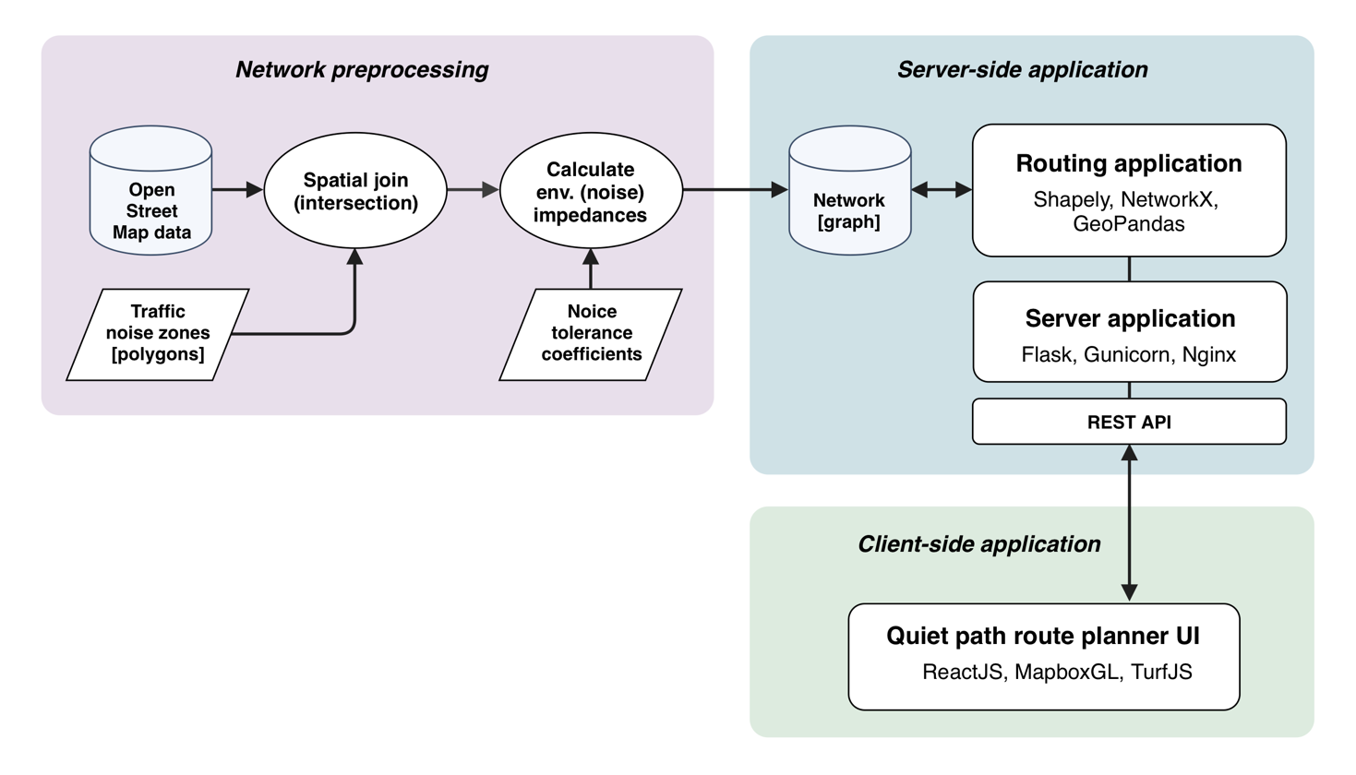

Figure 8. Technical architecture of the quiet path route planner web application.

The technical implementation of the quiet path route planner consists of three components: 1) network preparation for quiet path route optimization, 2) server-side quiet path optimization application and 3) client-side route planner user interface (Figure 8).

The quiet path optimization application relies on the environmental impedance function, network processing methods and route optimization method presented in the previous chapter. All of these were implemented with Python programming language by utilizing several external Python libraries. Hence, it was reasonable to implement also the server-side routing service as a Python application utilizing the very same methods.

A virtual machine was acquired for the purpose of publishing the quiet path route optimization as a web service. The machine was provided by CSC (CSC - IT Center for Science, Finland) and it came with Ubuntu 18.04 operating system preinstalled. Identical python environment as used locally (in developing the routing method) was configured to the virtual machine with Conda package manager.

In addition to the already developed functionalities, Python library Flask was installed to enable exploiting the routing application by web requests. Since Flask is not intended for high capacity production use, another Python library, Gunicorn, was configured to run the Python-Flask application in more efficient and secure manner. In practice, this meant running several independent routing applications in parallel and hence utilizing more of the available computing resources (of the virtual machine). Finally, in order to expose the services of the routing application to all internet, Nginx server software was installed to handle all incoming and outcoming connections to the machine.

An independent, interactive web map application was developed to serve as the user interface for the quiet path optimization service. It was implemented as ReactJS (**citation**) single page application (SPA). ReactJS is a powerful JavaScript framework for building interactive user interfaces and views. Mapbox GL (**citation**) was chosen as the mapping library due to its wide range of useful web mapping features, including interactive feature styling and good performance on mobile devices. This combination enabled building fully customized route planner interface for the purpose. Communication between the web map application and the routing service (at the virtual machine) was implemented with asynchronous functions; after routing request is sent from the client, a callback function (at the client) is invoked once the paths are returned from the routing service.

The features and functions of the route planner are described in more detail in the results chapter.

## Assessment of pedestrians’ exposure to traffic noise at neighborhood level

### Overview of the analysis

The assessment of pedestrians’ exposure to traffic noise at neighborhood level was implemented in two parts:

1. Identification of origin – PT stop (or commuting destination) walks and estimation of their utilization rates by origins.
2. Assessment of pedestrians’ exposure to traffic noise along walks from homes to local PT stops (or commuting destinations).

The analysis utilizes YKR commuting data which contains origin destination flows of commutes aggregated to 250 m grid.

In the following chapters, the word origin is used to refer to origins of the commutes.

Figure 9. Workflow of the analysis for identifying local PT stops and their utilization rates based on commutes.

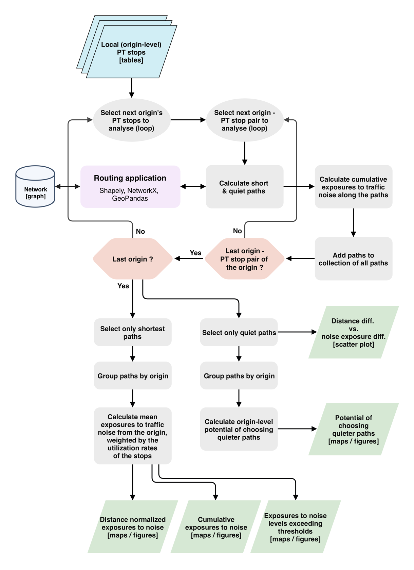

Figure 10. Workflow of the analysis for calculating paths between origins and PT stops.

### Estimation of local PT stops’ utilization rates by commutes

Local public transport (PT) stops were identified with extensive routing analysis (Figure 9). All commutes with origin in Helsinki were extracted from by YKR commuting data. For each commute, three public transport itineraries were requested from Digitransit routing API (Application Programming Interface) provided by the local public transport authority (Helsinki Region Transport / HRT). In the routing requests, walking speed was set as 70 m/min (Jäppinen, Toivonen, & Salonen, 2013; Toivonen et al., 2014). Default values were used for other routing parameters to model typical user preferences (Table 4). In some cases, if routing request did not result any itineraries, origin or target location was slightly adjusted in order to reach the underlying network.

The resulting itineraries of the routing analysis were aggregated at origin level. First walks of the itineraries were extracted and grouped by their targets. Two types of walks were found at this stage: 1) walks from origins to PT stops and 2) walks from origins to commuting destinations. Walks were grouped by their destinations and utilization rates of walks calculated for all unique origin-destination pairs.

Table 4. Parameters used in routing with Digitransit routing API.

|  |  |
| --- | --- |
| Parameter | Value |
| Origin | Center of the YKR grid cell |
| Destination | Destination of the commute |
| Date | Monday 8:30 am, 05/27/2019 |
| Walking speed | 70 m/min |
| Means of transport used | All except city bikes |
| Transfer safety margin | 0 min |
| Number of itineraries to suggest | 3 |

Several actions were taken to validate the results of the routing analysis. For each origin, sum of the utilization rates was compared to the total flow of commutes from the origin. Statistics of commuting destinations that fell outside the extent of the analysis were calculated for each origin.

### Least cost path calculations – short and quiet paths

Short and several alternative quiet paths were calculated for each origin – commuting destination (PT stop / workplace) pair. Noise tolerances 0.1, 0.15, 0.25, 0.5, 1, 1.5, 2, 4, 6, 10, 20 and 40 were used in the quiet path optimization. This set of noise tolerances had turned out to perform well in quiet path optimization, providing good balance between performance and path variability. The used set of noise tolerances resulted, in most cases, multiple identical or nearly identical routes – suggesting that using more comprehensive set of noise tolerances would not have resulted in more or better path alternatives for OD pairs.

### Spatial aggregation of exposures to traffic noise along the paths

The routing application developed in the study returned not only geometries of the short and quiet paths but also network edge-level information of exposures to different traffic noise levels (Figure 7). Hence, it was straightforward to sum cumulative exposures to different traffic noise levels at for short and quiet paths.

Subsequently, compressed indexes of exposures to traffic noises were calculated from the cumulative exposures at path level.

Mean noise exposure indexes were calculated for each origin by weighting the indexes with the utilization rates of the walks. This way, the mean exposure to noise at origin is the estimated exposure to traffic noise along a random walk from the origin (as part of a random commute).

### Assessment of pedestrians’ potential to reduce exposure to traffic noise with route choices

# Results

## Quiet path route planner web application

A typical user story that demonstrates the core functionality of the quiet path route planner application is presented in Figure 11. The user story covers a basic usage of the application, starting from defining origin and destination and finishing at choosing the path to take.

User can select origin and destination by clicking on the map. Address input was not implemented in this project since the main goal of the application was to serve as a simple proof of concept for novel quiet path route planner rather than replicating existing route planners’ functionality.

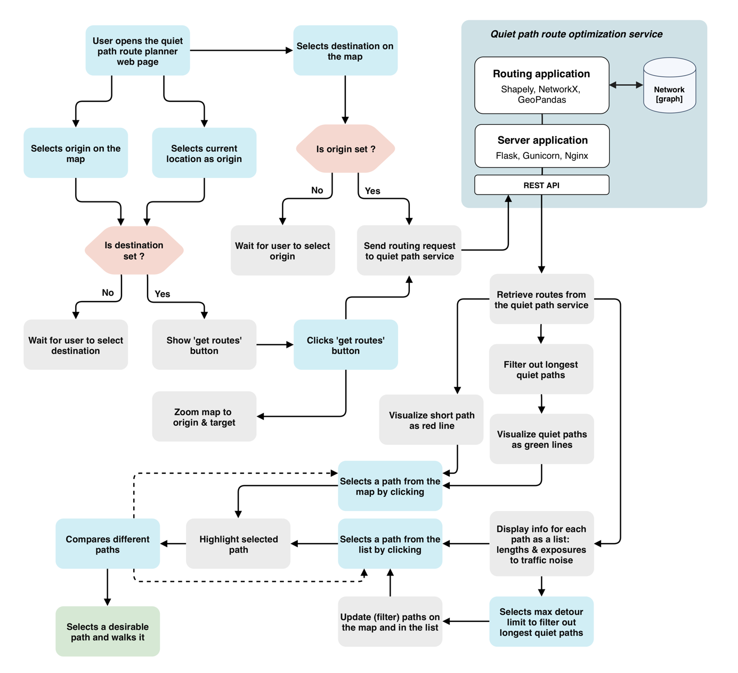

Figure 11. Typical user story demonstrating the core functionality of the quiet path route planner web application. (Blue/green = user’s actions; grey = actions at the user interface; white = components of the routing service).

Figure 12. Landing page of the quiet path route planner.

Figure 13. Display of path options and exposures to noise along the alternative paths.

Figure 14. Display of path alternatives.

Figure 15. Display of the route planner in a situation where no alternative quiet paths were found.

## Spatial patterns in pedestrians’ exposures to traffic noise

# Discussion

## Could traffic noise be used as a proxy for overall walkability?

## Indirect large-scale assessment of pedestrians’ exposures to traffic noise can reveal significant areal differences in walking conditions

## Considerable share of the exposure to traffic noise can often be avoided by taking an alternative path

## Definition of the environmental impedance function is critical yet somewhat arbitrary in quiet path optimization

## Alternative quiet paths need to be calculated to suit different situations and users with varying preferences

## Publishing a green path routing application online can facilitate citizens to choose healthier paths

## More efficient technical implementation is required to enable real-time green path route optimization

# Conclusions

# References

Apparicio, P., Carrier, M., Gelb, J., Séguin, A.-M., & Kingham, S. (2016). Cyclists’ exposure to air pollution and road traffic noise in central city neighbourhoods of Montreal. *Journal of Transport Geography*, *57*, 63–69.

Babisch, W., Beule, B., Schust, M., Kersten, N., & Ising, H. (2005). Traffic noise and risk of myocardial infarction. *Epidemiology*, 33–40.

Cole-Hunter, T., Morawska, L., Stewart, I., Jayaratne, R., & Solomon, C. (2012). Inhaled particle counts on bicycle commute routes of low and high proximity to motorised traffic. *Atmospheric Environment*, *61*, 197–203. https://doi.org/10.1016/j.atmosenv.2012.06.041

*Helsingin kaupungin meluselvitys 2017*. (2017). Retrieved from https://www.hel.fi/helsinki/fi/asuminen-ja-ymparisto/ymparistonsuojelu/ilmanlaatu-ja-melu/selvitys/

Ising, H., Dienel, D., Günther, T., & Markert, B. (1980). Health effects of traffic noise. *International Archives of Occupational and Environmental Health*, *47*(2), 179–190.

Jäppinen, S., Toivonen, T., & Salonen, M. (2013). Modelling the potential effect of shared bicycles on public transport travel times in Greater Helsinki: An open data approach. *Applied Geography*, *43*, 13–24. https://doi.org/10.1016/j.apgeog.2013.05.010

Lwin, K. K., & Murayama, Y. (2011). Modelling of urban green space walkability: Eco-friendly walk score calculator. *Computers, Environment and Urban Systems*, *35*(5), 408–420. https://doi.org/10.1016/j.compenvurbsys.2011.05.002

Lwin, K. K., & Murayama, Y. (2013). Smart eco-path finder for mobile GIS users. *URISA Journal*, *25*(2), 5–14.

Maghelal, P. K., & Capp, C. J. (2011). Walkability: A Review of Existing Pedestrian Indices. *Journal of the Urban & Regional Information Systems Association*, *23*(2).

Pucher, J., & Buehler, R. (2010). Walking and cycling for healthy cities. *Built Environment*, *36*(4), 391–414.

Quercia, D., Schifanella, R., & Aiello, L. M. (2014). The shortest path to happiness: Recommending beautiful, quiet, and happy routes in the city. *Proceedings of the 25th ACM Conference on Hypertext and Social Media*, 116–125. ACM.

Ribeiro, P., & Mendes, J. F. (2011). Route planning for soft modes of transport: healthy routes. *WIT Transactions on The Built Environment*, *116*, 677–688.

Sheng, N., & Tang, U. W. (2011). Spatial Analysis of Urban Form and Pedestrian Exposure to Traffic Noise. *International Journal of Environmental Research and Public Health*, *8*(6), 1977–1990. https://doi.org/10.3390/ijerph8061977

Tainio, M., de Nazelle, A. J., Götschi, T., Kahlmeier, S., Rojas-Rueda, D., Nieuwenhuijsen, M. J., … Woodcock, J. (2016). Can air pollution negate the health benefits of cycling and walking? *Preventive Medicine*, *87*, 233–236. https://doi.org/10.1016/j.ypmed.2016.02.002

Toivonen, T., Salonen, M., Tenkanen, H., Saarsalmi, P., Jaakkola, T., & Järvi, J. (2014). Joukkoliikenteellä, autolla ja kävellen: avoin saavutettavuusaineisto pääkaupunkiseudulta. *Terra 126 (2014): 3*.

Whyatt, J. D., Pooley, C., Coulton, P., Moser, M., Bamford, W., & Davies, G. (2007). Estimating personal exposure to air pollution on the journey to and from school using GPS, GIS and mobile phone technology. *11th International Conference on Harmonisation within Atmospheric Dispersion Modelling for Regulatory Purposes*, *1*, 2–5.